Оглавление

MainWindow.xaml 2

Mainwindow.xaml.cs 3

LoginWindow.xaml 4

LoginWindow.xaml.cs 5

CodeWindow.xaml 7

CodeWindow.xaml.cs 7

AuthStorage.cs 8

CodeClass.cs 8

AbonentPage.xaml 9

AbonentPage.xaml.cs 11

CrmPage.xaml 12

CrmPage.xaml.cs 13

AddPage.xaml 15

AddPage.xaml.cs 17

# MainWindow.xaml

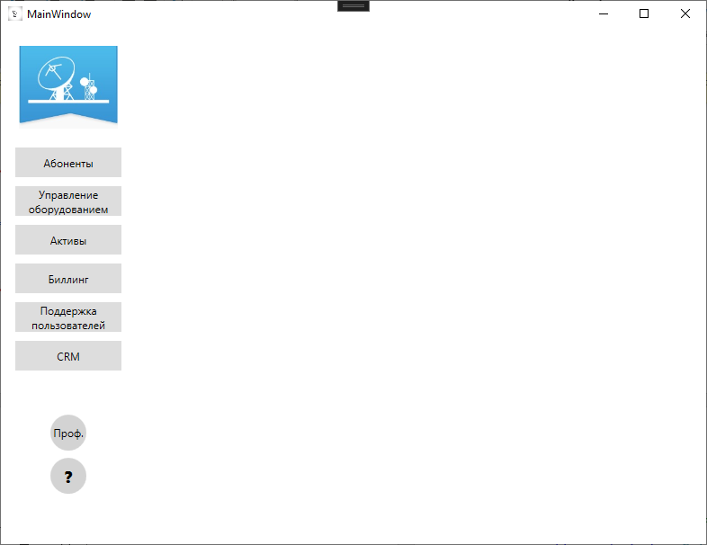

<Window x:Class="TelecomN.MainWindow"

xmlns="http://schemas.microsoft.com/winfx/2006/xaml/presentation"

xmlns:x="http://schemas.microsoft.com/winfx/2006/xaml"

xmlns:d="http://schemas.microsoft.com/expression/blend/2008"

xmlns:mc="http://schemas.openxmlformats.org/markup-compatibility/2006"

xmlns:local="clr-namespace:TelecomN"

mc:Ignorable="d"

Title="MainWindow" Height="550" Width="800">

<Grid>

<Grid.ColumnDefinitions>

<ColumnDefinition Width="150"/>

<ColumnDefinition/>

</Grid.ColumnDefinitions>

<StackPanel Orientation="Vertical" >

<Image Source="Resources\Лого ТНС.jpg" Margin="20"/>

<Button x:Name="AbonentBtn" BorderBrush="Transparent" Width="120" Height="35" VerticalAlignment="Center" HorizontalAlignment="Center" Content="Абоненты" Margin="0 0 0 8" Click="AbonentBtn_Click"/>

<Button x:Name="OborBtn" Width="120" BorderBrush="Transparent" Height="35" VerticalAlignment="Center" HorizontalAlignment="Center" Margin="0 0 0 8" Click="OborBtn_Click">

<TextBlock TextAlignment="Center">Управление

<LineBreak/>оборудованием</TextBlock>

</Button>

<Button BorderBrush="Transparent" x:Name="ActiveBtn" Width="120" Height="35" VerticalAlignment="Center" HorizontalAlignment="Center" Content="Активы" Margin="0 0 0 8" Click="ActiveBtn_Click"/>

<Button BorderBrush="Transparent" x:Name="BillingBtn" Width="120" Height="35" VerticalAlignment="Center" HorizontalAlignment="Center" Content="Биллинг" Margin="0 0 0 8" Click="BillingBtn_Click"/>

<Button x:Name="SupportBtn" Width="120" Height="35" BorderBrush="Transparent" VerticalAlignment="Center" HorizontalAlignment="Center" Margin="0 0 0 8" Click="SupportBtn_Click">

<TextBlock TextAlignment="Center">Поддержка

<LineBreak/>пользователей</TextBlock>

</Button>

<Button BorderBrush="Transparent" x:Name="CRMBtn" Width="120" Height="35" VerticalAlignment="Center" HorizontalAlignment="Center" Content="CRM" Margin="0 0 0 8" Click="CRMBtn_Click"/>

<StackPanel Orientation="Vertical" VerticalAlignment="Bottom" Margin="0 40 0 0">

<Border CornerRadius="30" Width="40" Height="40" Background="LightGray">

<Button x:Name="ProfBtn" Background="Transparent" BorderBrush="Transparent" Content="Проф." Click="ProfBtn_Click"/>

</Border>

<Border CornerRadius="30" Width="40" Height="40" Background="LightGray" Margin="0 8 0 0">

<Button x:Name="QuestionBtn" Background="Transparent" BorderBrush="Transparent" Content="?" FontSize="18" FontWeight="Heavy" Click="ProfBtn_Click"/>

</Border>

</StackPanel>

</StackPanel>

<Frame x:Name="MainFrame" ContentRendered="MainFrame_ContentRendered" NavigationUIVisibility="Hidden" Grid.Column="1"/>

</Grid>

</Window>

# Mainwindow.xaml.cs

using System;

using System.Collections.Generic;

using System.Linq;

using System.Text;

using System.Threading.Tasks;

using System.Windows;

using System.Windows.Controls;

using System.Windows.Data;

using System.Windows.Documents;

using System.Windows.Input;

using System.Windows.Media;

using System.Windows.Media.Imaging;

using System.Windows.Navigation;

using System.Windows.Shapes;

namespace TelecomN

{

/// <summary>

/// Логика взаимодействия для MainWindow.xaml

/// </summary>

public partial class MainWindow : Window

{

public MainWindow()

{

InitializeComponent();

}

/*переходит на станицу абонентов*/

private void AbonentBtn_Click(object sender, RoutedEventArgs e)

{

MainFrame.Navigate(new Pages.AbonentPage());

}

private void OborBtn_Click(object sender, RoutedEventArgs e)

{

}

private void ActiveBtn_Click(object sender, RoutedEventArgs e)

{

}

private void BillingBtn_Click(object sender, RoutedEventArgs e)

{

}

private void SupportBtn_Click(object sender, RoutedEventArgs e)

{

}

/*переход на страницу CRM*/

private void CRMBtn_Click(object sender, RoutedEventArgs e)

{

MainFrame.Navigate(new Pages.CrmPage());

}

private void ProfBtn_Click(object sender, RoutedEventArgs e)

{

}

private void MainFrame_ContentRendered(object sender, EventArgs e)

{

}

}

}

# LoginWindow.xaml

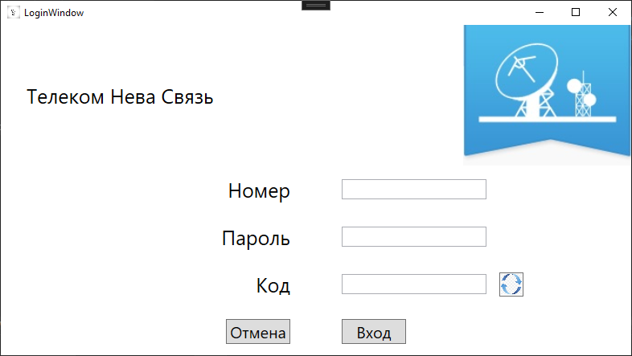

<Window x:Class="TelecomN.LoginWindow"

xmlns="http://schemas.microsoft.com/winfx/2006/xaml/presentation"

xmlns:x="http://schemas.microsoft.com/winfx/2006/xaml"

xmlns:d="http://schemas.microsoft.com/expression/blend/2008"

xmlns:mc="http://schemas.openxmlformats.org/markup-compatibility/2006"

xmlns:local="clr-namespace:TelecomN"

mc:Ignorable="d"

Title="LoginWindow" Height="450" Width="800">

<Grid>

<Grid.RowDefinitions>

<RowDefinition Height="175"/>

<RowDefinition/>

<RowDefinition/>

<RowDefinition/>

<RowDefinition/>

</Grid.RowDefinitions>

<Grid.ColumnDefinitions>

<ColumnDefinition/>

<ColumnDefinition/>

</Grid.ColumnDefinitions>

<TextBlock Text="Код" VerticalAlignment="Center" HorizontalAlignment="Right" FontSize="25" Grid.Row="3" Margin="32 0"/>

<StackPanel Orientation="Horizontal" Grid.Row="3" Grid.Column="1">

<TextBox x:Name="CodeTb" VerticalAlignment="Center" HorizontalAlignment="Left" Width="180" Margin="32 0 16 0" Height="25"/>

<Button x:Name="UpdBtn" VerticalAlignment="Center" Background="Transparent" Width="30" Height="30">

<Image VerticalAlignment="Center" HorizontalAlignment="Center" Source="\Resources\На авторизацию_Обновление кода.jpg" Width="30" Height="30"/>

</Button>

</StackPanel>

<Image Source="\Resources\Лого ТНС.jpg" Grid.Column="1" VerticalAlignment="Center" HorizontalAlignment="Right"/>

<TextBlock Text="Телеком Нева Связь" VerticalAlignment="Center" HorizontalAlignment="Left" Margin="32 0" FontSize="25"/>

<TextBlock Text="Номер" VerticalAlignment="Center" HorizontalAlignment="Right" FontSize="25" Grid.Row="1" Margin="32 0"/>

<TextBlock Text="Пароль" VerticalAlignment="Center" HorizontalAlignment="Right" FontSize="25" Grid.Row="2" Margin="32 0"/>

<Button x:Name="CancelBtn" VerticalAlignment="Center" HorizontalAlignment="Right" Grid.Row="4" Margin="32 0" Content="Отмена" Width="80" FontSize="20" Click="CancelBtn_Click"/>

<Button x:Name="AuthBtn" VerticalAlignment="Center" HorizontalAlignment="Left" Grid.Row="4" Margin="32 0" Click="AuthBtn_Click" Content="Вход" FontSize="20" Width="80" Grid.Column="1"/>

<TextBox x:Name="LoginTb" VerticalAlignment="Center" HorizontalAlignment="left" Margin="32 0" Grid.Row="1" Grid.Column="1" Width="180" Text="{Binding Login}" Height="25" />

<TextBox x:Name="PassTb" VerticalAlignment="Center" HorizontalAlignment="Left" Margin="32 0" Grid.Row="2" Grid.Column="1" Text="{Binding Password}" Width="180" Height="25"/>

</Grid>

</Window>

# LoginWindow.xaml.cs

using System;

using System.Collections.Generic;

using System.Linq;

using System.Text;

using System.Threading.Tasks;

using System.Windows;

using System.Windows.Controls;

using System.Windows.Data;

using System.Windows.Documents;

using System.Windows.Input;

using System.Windows.Media;

using System.Windows.Media.Imaging;

using System.Windows.Shapes;

using TelecomN.Modules;

using System.Timers;

namespace TelecomN

{

/// <summary>

/// Логика взаимодействия для LoginWindow.xaml

/// </summary>

public partial class LoginWindow : Window

{

public LoginWindow()

{

InitializeComponent();

DataContext = this;

}

/*кнопка отмены*/

private void CancelBtn_Click(object sender, RoutedEventArgs e)

{

MessageBoxResult messageBoxResult = MessageBox.Show("Вы действительно хотите закрыть?", "Закрыть", MessageBoxButton.OKCancel, MessageBoxImage.Question);

if (messageBoxResult == MessageBoxResult.OK)

{

this.Close();

}

}

/*кнопка авторизироваться*/

private void AuthBtn_Click(object sender, RoutedEventArgs e)

{

try

{

User user = TelecomNevaEntities.GetContext().Users.FirstOrDefault(p => p.PhoneNumb == LoginTb.Text && p.Password == PassTb.Text);

if (user != null)

{

if (CodeTb.Text == "")

{

CodeWindow code = new CodeWindow();

code.Show();

}

if (CodeTb.Text == CodeClass.Code)

{

AuthStorage.Role = user.RoleID;

AuthStorage.Name = user.PhoneNumb;

MainWindow mainWindow = new MainWindow();

mainWindow.Show();

this.Close();

}

}

else

{

MessageBox.Show("Неверные данные, пожалуйста, попробуйте еще раз");

}

}

catch (Exception ex)

{

MessageBox.Show(ex.Message.ToString());

}

}

/*кнопка для выведения кода*/

private void UpdBtn_Click(object sender, RoutedEventArgs e)

{

CodeWindow code = new CodeWindow();

code.Show();

}

}

}

# CodeWindow.xaml

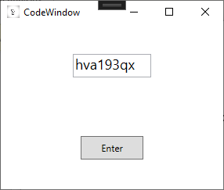

<Window x:Class="TelecomN.CodeWindow"

xmlns="http://schemas.microsoft.com/winfx/2006/xaml/presentation"

xmlns:x="http://schemas.microsoft.com/winfx/2006/xaml"

xmlns:d="http://schemas.microsoft.com/expression/blend/2008"

xmlns:mc="http://schemas.openxmlformats.org/markup-compatibility/2006"

xmlns:local="clr-namespace:TelecomN"

mc:Ignorable="d"

Title="CodeWindow" Height="250" Width="300">

<Grid>

<Grid.RowDefinitions>

<RowDefinition/>

<RowDefinition/>

</Grid.RowDefinitions>

<TextBox x:Name="CodeTb" Grid.Row="0" Width="100" Height="30" FontSize="18" HorizontalAlignment="Center" VerticalAlignment="Center" />

<Button x:Name="EnterBtn" Grid.Row="1" Width="80" Height="30" Content="Enter" VerticalAlignment="Center" HorizontalAlignment="Center" Click="EnterBtn_Click"/>

</Grid>

</Window>

# CodeWindow.xaml.cs

using System;

using System.Collections.Generic;

using System.Linq;

using System.Text;

using System.Threading.Tasks;

using System.Windows;

using System.Windows.Controls;

using System.Windows.Data;

using System.Windows.Documents;

using System.Windows.Input;

using System.Windows.Media;

using System.Windows.Media.Imaging;

using System.Windows.Shapes;

using System.IO;

using TelecomN.Modules;

using System.Timers;

namespace TelecomN

{

/// <summary>

/// Логика взаимодействия для CodeWindow.xaml

/// </summary>

public partial class CodeWindow : Window

{

string _code { get; set; }

public bool _isCorrect {get;set;}

public CodeWindow()

{

InitializeComponent();

_code = CodeClass.CreateCode();

CodeTb.Text = _code;

CodeClass.Code = _code;

}

/*кнопка входа*/

private void EnterBtn_Click(object sender, RoutedEventArgs e)

{

this.Close();

}

}

}

# AuthStorage.cs

using System;

using System.Collections.Generic;

using System.Linq;

using System.Text;

using System.Threading.Tasks;

namespace TelecomN.Modules

{

internal class AuthStorage

{

static public int Role { get; set; }

static public string Name { get; set; }

}

}

# CodeClass.cs

using System;

using System.Collections.Generic;

using System.Linq;

using System.Text;

using System.Threading.Tasks;

using System.Timers;

namespace TelecomN.Modules

{

internal class CodeClass

{

static public string Code;

static public string CreateCode()

{

Random rnd = new Random();

string code = "";

string codeElement = "qwertyuiopasdfghjklzxcvbnm1234567890" ;

for (int i = 0; i < 8; i++)

{

code = code + codeElement[rnd.Next(0, codeElement.Length)];

}

return code;

}

}

}

# AbonentPage.xaml

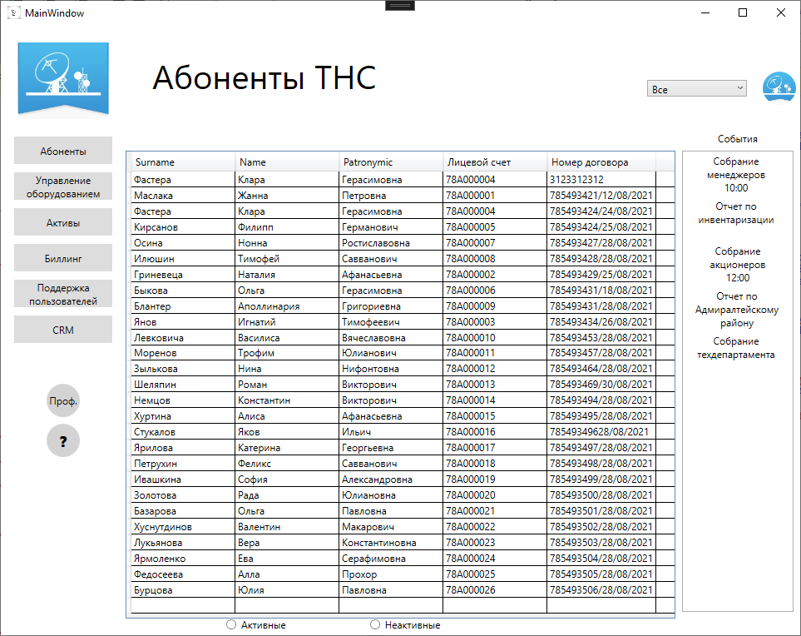

<Page x:Class="TelecomN.Pages.AbonentPage"

xmlns="http://schemas.microsoft.com/winfx/2006/xaml/presentation"

xmlns:x="http://schemas.microsoft.com/winfx/2006/xaml"

xmlns:mc="http://schemas.openxmlformats.org/markup-compatibility/2006"

xmlns:d="http://schemas.microsoft.com/expression/blend/2008"

xmlns:local="clr-namespace:TelecomN.Pages"

mc:Ignorable="d"

d:DesignHeight="450" d:DesignWidth="650"

Title="AbonentPage">

<Grid>

<Grid.RowDefinitions>

<RowDefinition Height="150"/>

<RowDefinition/>

<RowDefinition Height="20"/>

</Grid.RowDefinitions>

<Grid.ColumnDefinitions>

<ColumnDefinition/>

<ColumnDefinition Width="150"/>

</Grid.ColumnDefinitions>

<TextBlock Text="Абоненты ТНС" VerticalAlignment="Center" HorizontalAlignment="Left" FontSize="40" Margin="32 -32 0 0"/>

<ComboBox x:Name="UserCb" Width="120" Height="20" SelectionChanged="UserCb_SelectionChanged" VerticalAlignment="Center" HorizontalAlignment="Right" Margin="64 0" Grid.ColumnSpan="2"/>

<Ellipse Width="40" Height="40" Grid.Column="1" Margin="100 0 0 0">

<Ellipse.Fill>

<ImageBrush ImageSource="\Resources\Лого ТНС.jpg" Stretch="UniformToFill"/>

</Ellipse.Fill>

</Ellipse>

<DataGrid x:Name="AbonentData" Grid.Row="1" MinColumnWidth="125" ItemsSource="{Binding EjectApp}" AutoGenerateColumns="False">

<DataGrid.Columns>

<DataGridTextColumn Header="Surname" Binding="{Binding Abonent.LastName}"/>

<DataGridTextColumn Header="Name" Binding="{Binding Abonent.FirstName}"/>

<DataGridTextColumn Header="Patronymic" Binding="{Binding Abonent.Patronymic}"/>

<DataGridTextColumn Header="Лицевой счет" Binding="{Binding Abonent.AbonentID}"/>

<DataGridTextColumn Header="Номер договора" Binding="{Binding ApplicNumb}"/>

</DataGrid.Columns>

</DataGrid>

<Border Grid.Column="1" Grid.Row="0" Width="134" Background="White" Height="30" VerticalAlignment="Bottom">

<TextBlock Text="События" VerticalAlignment="Center" HorizontalAlignment="Center" />

</Border>

<ListBox Grid.Row="1" Grid.Column="1" Margin="8 0 8 8">

<ListBoxItem>

<TextBlock Text="Собрание менеджеров 10:00" TextAlignment="Center" Height="50" TextWrapping="Wrap" Margin="8 0" Width="100" VerticalAlignment="Center" HorizontalAlignment="Center"/>

</ListBoxItem>

<ListBoxItem>

<TextBlock Text="Отчет по инвентаризации" TextAlignment="Center" TextWrapping="Wrap" Height="50" Margin="8 0" Width="100" VerticalAlignment="Center" HorizontalAlignment="Center"/>

</ListBoxItem>

<ListBoxItem>

<TextBlock Text="Собрание акционеров 12:00" TextAlignment="Center" TextWrapping="Wrap" Height="50" Margin="20 0" Width="80" VerticalAlignment="Center" HorizontalAlignment="Center"/>

</ListBoxItem>

<ListBoxItem>

<TextBlock Text="Отчет по Адмиралтейскому району" TextAlignment="Center" TextWrapping="Wrap" Height="50" Margin="8 0" Width="102" VerticalAlignment="Center" HorizontalAlignment="Center"/>

</ListBoxItem>

<ListBoxItem>

<TextBlock Text="Собрание техдепартамента" TextAlignment="Center" TextWrapping="Wrap" Height="50" Margin="8 0" Width="100" VerticalAlignment="Center" HorizontalAlignment="Center"/>

</ListBoxItem>

</ListBox>

<StackPanel Orientation="Horizontal" Grid.Row="2" Margin="120 0">

<RadioButton x:Name="ActiveRb" Content="Активные" Checked="ActiveRb_Checked"/>

<RadioButton x:Name="NotActiveRb" Content="Неактивные" Margin="100 0" Checked="NotActiveRb_Checked"/>

</StackPanel>

</Grid>

</Page>

# AbonentPage.xaml.cs

using System;

using System.Collections.Generic;

using System.Linq;

using System.Text;

using System.Threading.Tasks;

using System.Windows;

using System.Windows.Controls;

using System.Windows.Data;

using System.Windows.Documents;

using System.Windows.Input;

using System.Windows.Media;

using System.Windows.Media.Imaging;

using System.Windows.Navigation;

using System.Windows.Shapes;

using TelecomN.Modules;

namespace TelecomN.Pages

{

/// <summary>

/// Логика взаимодействия для AbonentPage.xaml

/// </summary>

public partial class AbonentPage : Page

{

public List<EjectApp> Abonent { get; set; }

public AbonentPage()

{

InitializeComponent();

AbonentData.ItemsSource = null;

Abonent = TelecomNevaEntities.GetContext().EjectApps.ToList();

DataContext = this;

AbonentData.ItemsSource = Abonent;

List<Employee> employees = TelecomNevaEntities.GetContext().Employees.ToList();

employees.Insert(0, new Employee

{

Surname = "Все"

});

UserCb.ItemsSource = employees;

UserCb.DisplayMemberPath = "Surname";

UserCb.SelectedIndex = 0;

}

/*активные заказы*/

private void ActiveRb_Checked(object sender, RoutedEventArgs e)

{

List<EjectApp> abonents = TelecomNevaEntities.GetContext().EjectApps.Where(p => p.StatusID == 1 || p.StatusID == 2).ToList();

AbonentData.ItemsSource = abonents;

}

/*не активные заказы*/

private void NotActiveRb_Checked(object sender, RoutedEventArgs e)

{

List<EjectApp> ejects = TelecomNevaEntities.GetContext().EjectApps.Where(p => p.StatusID == 3).ToList();

AbonentData.ItemsSource = ejects;

}

/*метод для обновления данных*/

private void Update()

{

List<EjectApp> ejects = TelecomNevaEntities.GetContext().EjectApps.ToList();

if (UserCb.SelectedIndex > 0)

{

ejects = ejects.Where(p=> p.EmployeeID == (UserCb.SelectedItem as Employee).EmployeeID).ToList();

}

AbonentData.ItemsSource = ejects;

}

private void UserCb_SelectionChanged(object sender, SelectionChangedEventArgs e)

{

Update();

}

}

}

# CrmPage.xaml

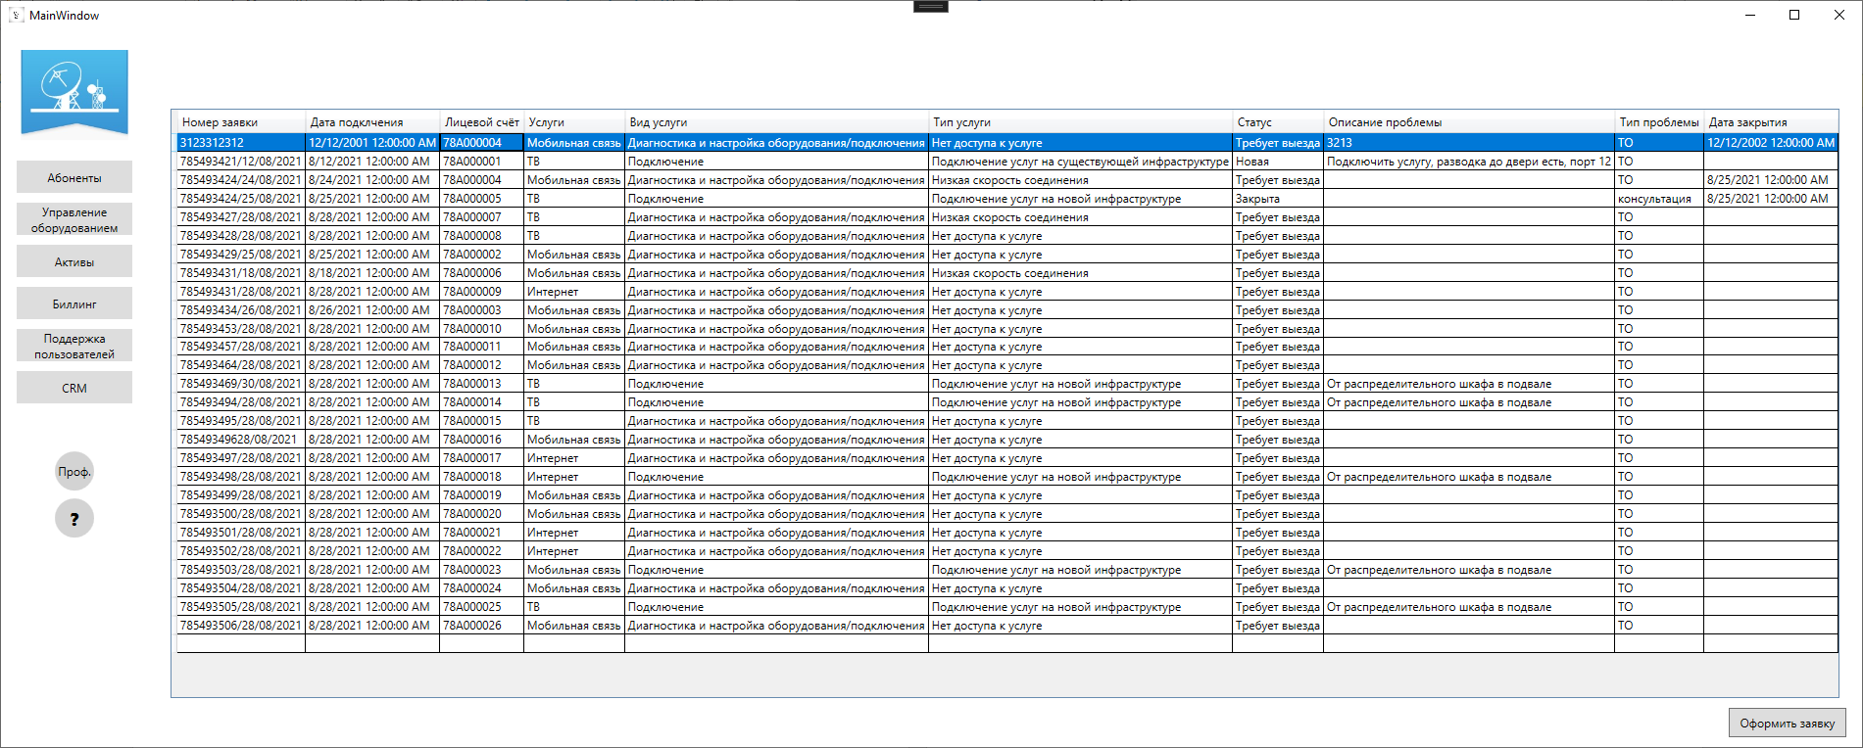

<Page x:Class="TelecomN.Pages.CrmPage"

xmlns="http://schemas.microsoft.com/winfx/2006/xaml/presentation"

xmlns:x="http://schemas.microsoft.com/winfx/2006/xaml"

xmlns:mc="http://schemas.openxmlformats.org/markup-compatibility/2006"

xmlns:d="http://schemas.microsoft.com/expression/blend/2008"

xmlns:local="clr-namespace:TelecomN.Pages"

mc:Ignorable="d"

d:DesignHeight="450" d:DesignWidth="800"

Title="CrmPage">

<Grid>

<Grid.RowDefinitions>

<RowDefinition Height="80"/>

<RowDefinition/>

<RowDefinition Height="50"/>

</Grid.RowDefinitions>

<DataGrid x:Name="CRMData" AutoGenerateColumns="False" ItemsSource="{Binding Application}" HorizontalAlignment="Center" Grid.Row="1">

<DataGrid.Columns>

<DataGridTextColumn Header="Номер заявки" Binding="{Binding ApplicNumb}"/>

<DataGridTextColumn Header="Дата подклчения" Binding="{Binding DateOfStart}"/>

<DataGridTextColumn Header="Лицевой счёт" Binding="{Binding AbonentID}"/>

<DataGridTextColumn Header="Услуги" Binding="{Binding Service.Name}"/>

<DataGridTextColumn Header="Вид услуги" Binding="{Binding ServiceView.Name}"/>

<DataGridTextColumn Header="Тип услуги" Binding="{Binding ServiceType.Name}"/>

<DataGridTextColumn Header="Статус" Binding="{Binding Status.Name}"/>

<DataGridTextColumn Header="Описание проблемы" Binding="{Binding Opisanie}"/>

<DataGridTextColumn Header="Тип проблемы" Binding="{Binding Problem.Name}"/>

<DataGridTextColumn Header="Дата закрытия" Binding="{Binding DateOfRealiz}"/>

</DataGrid.Columns>

</DataGrid>

<Button x:Name="AddBtn" Content="Оформить заявку" Grid.Row="2" VerticalAlignment="Center"

HorizontalAlignment="Right" Margin="16 0" Width="120" Height="30" Click="AddBtn_Click" />

</Grid>

</Page>

# CrmPage.xaml.cs

using System;

using System.Collections.Generic;

using System.Linq;

using System.Text;

using System.Threading.Tasks;

using System.Windows;

using System.Windows.Controls;

using System.Windows.Data;

using System.Windows.Documents;

using System.Windows.Input;

using System.Windows.Media;

using System.Windows.Media.Imaging;

using System.Windows.Navigation;

using System.Windows.Shapes;

using TelecomN.Modules;

namespace TelecomN.Pages

{

/// <summary>

/// Логика взаимодействия для CrmPage.xaml

/// </summary>

public partial class CrmPage : Page

{

public List<EjectApp> Applications { get; set; }

public CrmPage()

{

InitializeComponent();

CRMData.ItemsSource = null;

Applications = TelecomNevaEntities.GetContext().EjectApps.ToList();

DataContext = this;

CRMData.ItemsSource = Applications;

}

/*кнопка для доавбления новой заявки на страницу CRM*/

private void AddBtn_Click(object sender, RoutedEventArgs e)

{

NavigationService.Navigate(new Pages.AddPage());

}

}

}

# AddPage.xaml

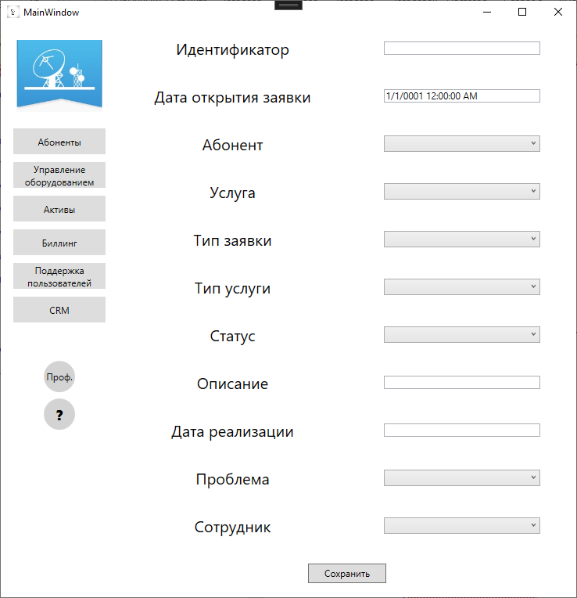

<Page x:Class="TelecomN.Pages.AddPage"

xmlns="http://schemas.microsoft.com/winfx/2006/xaml/presentation"

xmlns:x="http://schemas.microsoft.com/winfx/2006/xaml"

xmlns:mc="http://schemas.openxmlformats.org/markup-compatibility/2006"

xmlns:d="http://schemas.microsoft.com/expression/blend/2008"

xmlns:local="clr-namespace:TelecomN.Pages"

mc:Ignorable="d"

d:DesignHeight="450" d:DesignWidth="800"

Title="AddPage">

<Grid>

<Grid.RowDefinitions>

<RowDefinition/>

<RowDefinition/>

<RowDefinition/>

<RowDefinition/>

<RowDefinition/>

<RowDefinition/>

<RowDefinition/>

<RowDefinition/>

<RowDefinition/>

<RowDefinition/>

<RowDefinition/>

<RowDefinition/>

</Grid.RowDefinitions>

<Grid.ColumnDefinitions>

<ColumnDefinition/>

<ColumnDefinition/>

</Grid.ColumnDefinitions>

<TextBlock Text="Идентификатор" VerticalAlignment="Center" HorizontalAlignment="Center" Grid.Row="0" FontSize="20"/>

<TextBlock Text="Дата открытия заявки" VerticalAlignment="Center" HorizontalAlignment="Center" Grid.Row="1" FontSize="20"/>

<TextBlock Text="Абонент" VerticalAlignment="Center" HorizontalAlignment="Center" Grid.Row="2" FontSize="20"/>

<TextBlock Text="Услуга" VerticalAlignment="Center" HorizontalAlignment="Center" Grid.Row="3" FontSize="20"/>

<TextBlock Text="Тип заявки" VerticalAlignment="Center" HorizontalAlignment="Center" Grid.Row="4" FontSize="20"/>

<TextBlock Text="Тип услуги" VerticalAlignment="Center" HorizontalAlignment="Center" Grid.Row="5" FontSize="20"/>

<TextBlock Text="Статус" VerticalAlignment="Center" HorizontalAlignment="Center" Grid.Row="6" FontSize="20"/>

<TextBlock Text="Описание" VerticalAlignment="Center" HorizontalAlignment="Center" Grid.Row="7" FontSize="20"/>

<TextBlock Text="Дата реализации" VerticalAlignment="Center" HorizontalAlignment="Center" Grid.Row="8" FontSize="20"/>

<TextBlock Text="Проблема" VerticalAlignment="Center" HorizontalAlignment="Center" Grid.Row="9" FontSize="20"/>

<TextBlock Text="Сотрудник" VerticalAlignment="Center" HorizontalAlignment="Center" Grid.Row="10" FontSize="20"/>

<Button x:Name="SaveBtn" VerticalAlignment="Center" HorizontalAlignment="Center" Grid.ColumnSpan="2"

Click="SaveBtn_Click" Grid.Row="11" Content="Сохранить" Width="100" Height="25"/>

<TextBox Text="{Binding ApplicNumb}" VerticalAlignment="Center" HorizontalAlignment="Center" Grid.Row="0" Grid.Column="1" Width="200"/>

<TextBox x:Name="DayTb" Text="{Binding DateOfStart}" VerticalAlignment="Center" HorizontalAlignment="Center" Grid.Row="1" Grid.Column="1" Width="200"/>

<ComboBox x:Name="AbonentCb" Grid.Row="2" Grid.Column="1" SelectedItem="{Binding Abonent}" DisplayMemberPath="AbonentID" VerticalAlignment="Center" HorizontalAlignment="Center" Width="200" />

<ComboBox x:Name="ServiceCb" Grid.Row="3" Grid.Column="1" SelectedItem="{Binding Service}" DisplayMemberPath="Name" VerticalAlignment="Center" HorizontalAlignment="Center" Width="200" />

<ComboBox x:Name="SerViewCb" Grid.Row="4" Grid.Column="1" SelectedItem="{Binding ServiceView}" DisplayMemberPath="Name" VerticalAlignment="Center" HorizontalAlignment="Center" Width="200" />

<ComboBox x:Name="SerTypeCb" Grid.Row="5" Grid.Column="1" SelectedItem="{Binding ServiceType}" DisplayMemberPath="Name" VerticalAlignment="Center" HorizontalAlignment="Center" Width="200" />

<ComboBox x:Name="StatusCb" Grid.Row="6" Grid.Column="1" SelectedItem="{Binding Status}" DisplayMemberPath="Name" VerticalAlignment="Center" HorizontalAlignment="Center" Width="200" />

<TextBox Text="{Binding Opisanie}" VerticalAlignment="Center" HorizontalAlignment="Center" Grid.Row="7" Grid.Column="1" Width="200"/>

<TextBox x:Name="DaydTb" Text="{Binding DateOfRealiz}" VerticalAlignment="Center" HorizontalAlignment="Center" Grid.Row="8" Grid.Column="1" Width="200"/>

<ComboBox x:Name="ProblemCb" Grid.Row="9" Grid.Column="1" SelectedItem="{Binding Problem}" DisplayMemberPath="Name" VerticalAlignment="Center" HorizontalAlignment="Center" Width="200" />

<ComboBox x:Name="EmployeeCb" Grid.Row="10" Grid.Column="1" SelectedItem="{Binding Employee}" DisplayMemberPath="Surname" VerticalAlignment="Center" HorizontalAlignment="Center" Width="200" />

</Grid>

</Page>

# AddPage.xaml.cs

using System;

using System.Collections.Generic;

using System.Drawing;

using System.Linq;

using System.Text;

using System.Threading.Tasks;

using System.Windows;

using System.Windows.Controls;

using System.Windows.Data;

using System.Windows.Documents;

using System.Windows.Input;

using System.Windows.Media;

using System.Windows.Media.Imaging;

using System.Windows.Navigation;

using System.Windows.Shapes;

using TelecomN.Modules;

namespace TelecomN.Pages

{

/// <summary>

/// Логика взаимодействия для AddPage.xaml

/// </summary>

public partial class AddPage : Page

{

public EjectApp EjectApps { get; set; }

public AddPage()

{

InitializeComponent();

EjectApps = new EjectApp();

AbonentCb.ItemsSource = TelecomNevaEntities.GetContext().Abonents.ToList();

EmployeeCb.ItemsSource = TelecomNevaEntities.GetContext().Employees.ToList();

ProblemCb.ItemsSource = TelecomNevaEntities.GetContext().Problems.ToList();

SerTypeCb.ItemsSource = TelecomNevaEntities.GetContext().ServiceTypes.ToList();

ServiceCb.ItemsSource = TelecomNevaEntities.GetContext().Services.ToList();

SerViewCb.ItemsSource = TelecomNevaEntities.GetContext().ServiceViews.ToList();

StatusCb.ItemsSource = TelecomNevaEntities.GetContext().Status.ToList();

StatusCb.SelectedIndex = 0;

DataContext = EjectApps;

}

/*кнопка сохранить данные*/

private void SaveBtn_Click(object sender, RoutedEventArgs e)

{

try

{

EjectApps.AbonentID = (AbonentCb.SelectedItem as Abonent).AbonentID;

EjectApps.EmployeeID = (EmployeeCb.SelectedItem as Employee).EmployeeID;

EjectApps.ProblemID = (ProblemCb.SelectedItem as Problem).ProblemID;

EjectApps.ServTypeID = (SerTypeCb.SelectedItem as ServiceType).ServTypeID;

EjectApps.ServiceID = (ServiceCb.SelectedItem as Service).ServiceID;

EjectApps.ServViewID = (SerViewCb.SelectedItem as ServiceView).ServViewID;

EjectApps.StatusID = (StatusCb.SelectedItem as Status).StatusID;

if (EjectApps.ApplicNumb != null)

{

TelecomNevaEntities.GetContext().EjectApps.Add(EjectApps);

}

TelecomNevaEntities.GetContext().SaveChanges();

NavigationService.GoBack();

}

catch (Exception ex)

{

MessageBox.Show(ex.InnerException.Message);

}

}

}

}